Access the Synapse WorkSpace to view the Archived parquet files.

1. Open SSMS

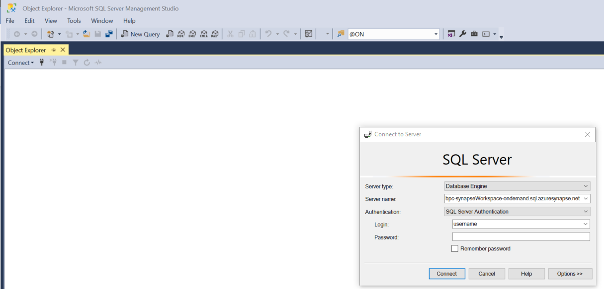

2. Click on the “Options >>” button on the lower right of the “Connect to Server” window. Make sure the “Encrypt connection” box is checked.

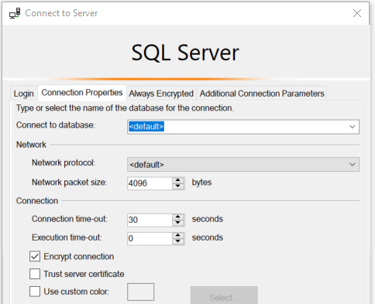

3. Click on the “Options >>” button on the lower right of the “Connect to Server” window to go back. Enter the following for the Servername:

* bpc-synapseWorkspace-ondemand.sql.azuresynapse.net
  + Note: change the “synapseWorkSpace” to your workspace name.
* Enter your provided login and password and click on the “connect” button.

4. You should now be connected to your Synapse Workspace.

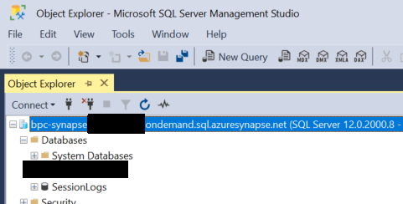

5. To query the parquet files Right click on the SessionLogs database and select “New Query.”

